1. 📋 Applicability Checklist
Use this checklist to assess whether and how the chapter's theory applies to your project:
Applicability Checklist — Correlation, Association & Simpson's Paradox
Evaluate your project against each criterion below before applying the chapter's methods.
# | Criterion | Question to Ask | ✅ / ❌
1 | Treatment variable exists | Is there a binary or continuous variable whose "effect" you want to measure?
2 | Outcome variable defined | Is there a clear outcome (binary disease/event or continuous)?
3 | Potential confounders identified | Can you list variables that affect both treatment assignment and outcome?
4 | Non-randomized data | Is treatment not randomly assigned (observational study)?
5 | Subgroup structure available | Can you stratify data by confounder levels (e.g., severity, department)?
6 | Marginal vs. conditional sign check | Have you compared the marginal association sign to the conditional sign(s)?
7 | Appropriate association measure chosen | RD, RR, or OR depending on study design and outcome rarity?
8 | Statistical testing planned | Fisher's exact test or chi-square test for contingency tables?
9 | Regression specification considered | Have you checked whether adding/removing covariates changes the coefficient sign?
10 | Interpretation framed carefully | Are you avoiding causal language for purely associational results?
11 | Data aggregation reviewed | Have you checked whether pooled results reverse subgroup trends?
12 | Domain expert consulted | Has a subject-matter expert validated candidate confounders?

2. 🔑 Key Takeaways
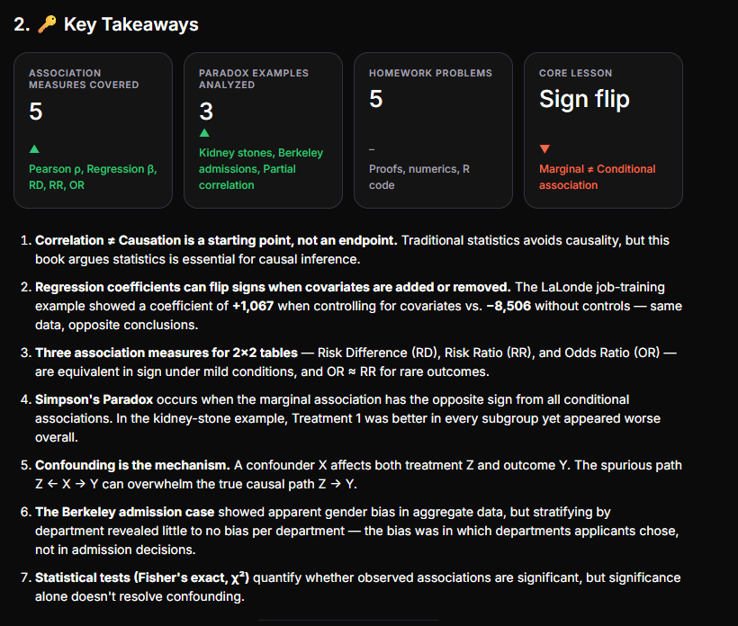
▼Marginal ≠ Conditional association
- Correlation ≠ Causation is a starting point, not an endpoint. Traditional statistics avoids causality, but this book argues statistics is essential for causal inference.
- Regression coefficients can flip signs when covariates are added or removed. The LaLonde job-training example showed a coefficient of +1,067 when controlling for covariates vs. −8,506 without controls — same data, opposite conclusions.
- Three association measures for 2×2 tables — Risk Difference (RD), Risk Ratio (RR), and Odds Ratio (OR) — are equivalent in sign under mild conditions, and OR ≈ RR for rare outcomes.
- Simpson's Paradox occurs when the marginal association has the opposite sign from all conditional associations. In the kidney-stone example, Treatment 1 was better in every subgroup yet appeared worse overall.
- Confounding is the mechanism. A confounder X affects both treatment Z and outcome Y. The spurious path Z ← X → Y can overwhelm the true causal path Z → Y.
- The Berkeley admission case showed apparent gender bias in aggregate data, but stratifying by department revealed little to no bias per department — the bias was in which departments applicants chose, not in admission decisions.
- Statistical tests (Fisher's exact, χ²) quantify whether observed associations are significant, but significance alone doesn't resolve confounding.

3. 📓 Reusable Jupyter Notebook Template (.json)
Below is a valid Jupyter Notebook JSON you can save as causal_inference_ch1_template.ipynb:
{ "cells": [ { "cell_type": "markdown", "metadata": {}, "source": [ "# Chapter 1: Correlation, Association & the Yule–Simpson Paradox\n", "\n", "## Reusable Analysis Template\n", "\n", "This notebook implements:\n", "1. Pearson correlation & linear/multiple regression\n", "2. 2×2 contingency table analysis (RD, RR, OR)\n", "3. Fisher's exact test & Chi-square test\n", "4. Simpson's Paradox detection\n", "5. Stratified subgroup analysis\n", "6. Specification search over covariate subsets" ] }, { "cell_type": "code", "execution_count": null, "metadata": {}, "outputs": [], "source": [ "import numpy as np\n", "import pandas as pd\n", "from scipy import stats\n", "from itertools import combinations\n", "import warnings\n", "warnings.filterwarnings('ignore')\n", "\n", "# ============================================================\n", "# SECTION 1: Pearson Correlation & Linear Regression\n", "# ============================================================\n", "\n", "def pearson_correlation(z, y):\n", " \"\"\"Compute Pearson correlation between two arrays.\"\"\"\n", " rho = np.corrcoef(z, y)[0, 1]\n", " print(f'Pearson correlation ρ_ZY = {rho:.4f}')\n", " return rho\n", "\n", "def simple_vs_multiple_regression(df, treatment, outcome, covariates):\n", " \"\"\"Compare simple regression vs. multiple regression coefficients.\n", " Demonstrates sign-flip phenomenon (LaLonde-style).\n", " \"\"\"\n", " import statsmodels.api as sm\n", "\n", " # Simple regression (no controls)\n", " X_simple = sm.add_constant(df[treatment])\n", " model_simple = sm.OLS(df[outcome], X_simple).fit()\n", " beta_simple = model_simple.params[treatment]\n", "\n", " # Multiple regression (all controls)\n", " X_multi = sm.add_constant(df[[treatment] + covariates])\n", " model_multi = sm.OLS(df[outcome], X_multi).fit()\n", " beta_multi = model_multi.params[treatment]\n", "\n", " print(f'Simple regression β ({treatment}): {beta_simple:.4f} (p={model_simple.pvalues[treatment]:.4f})')\n", " print(f'Multiple regression β ({treatment}): {beta_multi:.4f} (p={model_multi.pvalues[treatment]:.4f})')\n", "\n", " if np.sign(beta_simple) != np.sign(beta_multi):\n", " print('⚠️ SIGN FLIP detected! Covariates reversed the direction of association.')\n", " else:\n", " print('No sign flip detected.')\n", "\n", " return {'simple_beta': beta_simple, 'multi_beta': beta_multi}" ] }, { "cell_type": "code", "execution_count": null, "metadata": {}, "outputs": [], "source": [ "# ============================================================\n", "# SECTION 2: 2×2 Contingency Table Analysis\n", "# ============================================================\n", "\n", "def contingency_table_analysis(table, labels=('Z=1', 'Z=0')):\n", " \"\"\"\n", " Given a 2×2 table as [[n11, n10], [n01, n00]],\n", " compute RD, RR, OR and run Fisher's exact & Chi-square tests.\n", " \"\"\"\n", " table = np.array(table, dtype=float)\n", " n11, n10 = table[0]\n", " n01, n00 = table[1]\n", "\n", " # Risk (probability of Y=1) under each treatment\n", " p1 = n11 / (n11 + n10) # P(Y=1 | Z=1)\n", " p0 = n01 / (n01 + n00) # P(Y=1 | Z=0)\n", "\n", " rd = p1 - p0\n", " rr = p1 / p0 if p0 > 0 else float('inf')\n", " or_val = (n11 * n00) / (n10 * n01) if (n10 * n01) > 0 else float('inf')\n", "\n", " # Fisher's exact test\n", " fisher = stats.fisher_exact(table.astype(int))\n", " # Chi-square test\n", " chi2, chi2_p, _, _ = stats.chi2_contingency(table.astype(int), correction=False)\n", "\n", " print(f'Table: {labels[0]} vs {labels[1]}')\n", " print(f' P(Y=1|Z=1) = {p1:.4f} | P(Y=1|Z=0) = {p0:.4f}')\n", " print(f' Risk Difference (RD) = {rd:+.4f}')\n", " print(f' Risk Ratio (RR) = {rr:.4f}')\n", " print(f' Odds Ratio (OR) = {or_val:.4f}')\n", " print(f' Fisher exact p-value = {fisher[1]:.6f}')\n", " print(f' Chi-square p-value = {chi2_p:.6f}')\n", " print()\n", "\n", " return {'rd': rd, 'rr': rr, 'or': or_val,\n", " 'fisher_p': fisher[1], 'chi2_p': chi2_p}" ] }, { "cell_type": "code", "execution_count": null, "metadata": {}, "outputs": [], "source": [ "# ============================================================\n", "# SECTION 3: Simpson's Paradox Detector\n", "# ============================================================\n", "\n", "def detect_simpsons_paradox(marginal_table, subgroup_tables):\n", " \"\"\"\n", " Detects Simpson's Paradox by comparing the sign of the marginal RD\n", " to the signs of all subgroup RDs.\n", "\n", " Parameters:\n", " - marginal_table: 2×2 array for the whole population\n", " - subgroup_tables: list of 2×2 arrays, one per subgroup\n", " \"\"\"\n", " marginal_rd = contingency_table_analysis(marginal_table)['rd']\n", " marginal_sign = np.sign(marginal_rd)\n", "\n", " subgroup_signs = []\n", " for i, sg_table in enumerate(subgroup_tables):\n", " sg_result = contingency_table_analysis(sg_table)\n", " subgroup_signs.append(np.sign(sg_result['rd']))\n", "\n", " all_subgroup_same = all(s == subgroup_signs[0] for s in subgroup_signs)\n", " all_opposite_to_marginal = all(s != marginal_sign for s in subgroup_signs)\n", "\n", " if all_subgroup_same and all_opposite_to_marginal:\n", " print('🚨 SIMPSON\\'S PARADOX DETECTED!')\n", " print(f' Marginal RD sign: {marginal_sign:+.0f}')\n", " print(f' All subgroup RD signs: {[f\\\"{s:+.0f}\\\" for s in subgroup_signs]}')\n", " print(f' The marginal association reverses ALL conditional associations.')\n", " elif marginal_sign != subgroup_signs[0]:\n", " print('⚠️ Partial sign reversal detected (not full Simpson\\'s Paradox).')\n", " else:\n", " print('✅ No Simpson\\'s Paradox detected.')\n", "\n", " return {'marginal_rd': marginal_rd,\n", " 'subgroup_rds': [contingency_table_analysis(t)['rd'] for t in subgroup_tables]}" ] }, { "cell_type": "code", "execution_count": null, "metadata": {}, "outputs": [], "source": [ "# ============================================================\n", "# SECTION 4: Kidney Stone Example (from the chapter)\n", "# ============================================================\n", "\n", "print('='*60)\n", "print('KIDNEY STONE EXAMPLE')\n", "print('='*60)\n", "\n", "# Marginal (whole population)\n", "kidney_marginal = [[273, 77], [289, 61]]\n", "\n", "# Subgroup: smaller stones (X=1)\n", "kidney_small = [[81, 6], [234, 36]]\n", "\n", "# Subgroup: larger stones (X=0)\n", "kidney_large = [[192, 71], [55, 25]]\n", "\n", "detect_simpsons_paradox(kidney_marginal, [kidney_small, kidney_large])" ] }, { "cell_type": "code", "execution_count": null, "metadata": {}, "outputs": [], "source": [ "# ============================================================\n", "# SECTION 5: Berkeley Admissions Example\n", "# ============================================================\n", "\n", "print('='*60)\n", "print('BERKELEY ADMISSIONS EXAMPLE')\n", "print('='*60)\n", "\n", "# Department-wise data: [[Male Admitted, Male Rejected], [Female Admitted, Female Rejected]]\n", "berkeley_depts = {\n", " 'A': [[512, 313], [89, 19]],\n", " 'B': [[353, 207], [17, 8]],\n", " 'C': [[120, 205], [202, 391]],\n", " 'D': [[138, 279], [131, 244]],\n", " 'E': [[53, 138], [94, 299]],\n", " 'F': [[22, 351], [24, 317]],\n", "}\n", "\n", "# Aggregate (marginal) table\n", "male_total_admit = sum(d[0][0] for d in berkeley_depts.values())\n", "male_total_reject = sum(d[0][1] for d in berkeley_depts.values())\n", "female_total_admit = sum(d[1][0] for d in berkeley_depts.values())\n", "female_total_reject = sum(d[1][1] for d in berkeley_depts.values())\n", "berkeley_marginal = [[male_total_admit, male_total_reject],\n", " [female_total_admit, female_total_reject]]\n", "\n", "print('\\n--- MARGINAL (aggregated) ---')\n", "contingency_table_analysis(berkeley_marginal)\n", "\n", "print('--- BY DEPARTMENT ---')\n", "dept_results = []\n", "for dept, tbl in berkeley_depts.items():\n", " print(f'Department {dept}:')\n", " r = contingency_table_analysis(tbl)\n", " dept_results.append((dept, r))" ] }, { "cell_type": "code", "execution_count": null, "metadata": {}, "outputs": [], "source": [ "# ============================================================\n", "# SECTION 6: Specification Search (Problem 1.4)\n", "# ============================================================\n", "\n", "def specification_search(df, treatment, outcome, covariates):\n", " \"\"\"\n", " Run all 2^p subsets of covariates in linear regression,\n", " classify treatment coefficient as positive sig, negative sig, or not sig.\n", " \"\"\"\n", " import statsmodels.api as sm\n", "\n", " n_subsets = 2 ** len(covariates)\n", " results = []\n", "\n", " for k in range(len(covariates) + 1):\n", " for combo in combinations(covariates, k):\n", " cols = [treatment] + list(combo)\n", " X = sm.add_constant(df[cols])\n", " model = sm.OLS(df[outcome], X).fit()\n", " beta = model.params[treatment]\n", " pval = model.pvalues[treatment]\n", "\n", " if pval < 0.05 and beta > 0:\n", " category = 'positive_sig'\n", " elif pval < 0.05 and beta < 0:\n", " category = 'negative_sig'\n", " else:\n", " category = 'not_sig'\n", "\n", " results.append({\n", " 'covariates': combo,\n", " 'beta': beta,\n", " 'p_value': pval,\n", " 'category': category\n", " })\n", "\n", " df_results = pd.DataFrame(results)\n", " counts = df_results['category'].value_counts()\n", "\n", " print(f'Total regressions run: {len(results)}')\n", " print(f' Positive & significant: {counts.get(\"positive_sig\", 0)}')\n", " print(f' Negative & significant: {counts.get(\"negative_sig\", 0)}')\n", " print(f' Not significant: {counts.get(\"not_sig\", 0)}')\n", "\n", " return df_results" ] }, { "cell_type": "markdown", "metadata": {}, "source": [ "## How to Use This Template\n", "\n", "1. **Load your data** into a pandas DataFrame\n", "2. Call `simple_vs_multiple_regression()` to check for sign flips\n", "3. Build 2×2 tables and call `contingency_table_analysis()` for RD, RR, OR, and hypothesis tests\n", "4. Use `detect_simpsons_paradox()` to compare marginal vs. subgroup associations\n", "5. Use `specification_search()` to exhaustively check all covariate subsets" ] } ], "metadata": { "kernelspec": { "display_name": "Python 3", "language": "python", "name": "python3" }, "language_info": { "codemirror_mode": {"name": "ipython", "version": 3}, "file_extension": ".py", "mimetype": "text/x-python", "name": "python", "nbconvert_exporter": "python", "pygments_lexer": "ipython3", "version": "3.10.0" } }, "nbformat": 4, "nbformat_minor": 4}

4. ✏️ Solutions and Explanations to Exercises

Problem 1.1 — Independence in 2×2 Tables
Statement to prove (Proposition 1.1):

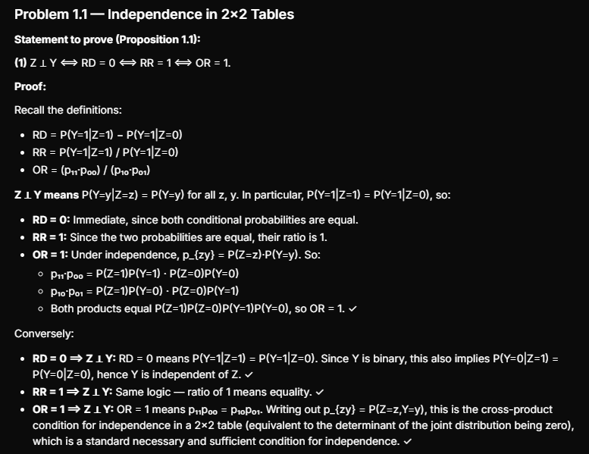
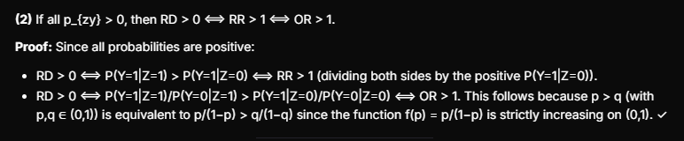
(1) Z ⊥ Y ⟺ RD = 0 ⟺ RR = 1 ⟺ OR = 1.
Proof:
Recall the definitions:
- RD = P(Y=1|Z=1) − P(Y=1|Z=0)
- RR = P(Y=1|Z=1) / P(Y=1|Z=0)
- OR = (p₁₁·p₀₀) / (p₁₀·p₀₁)
Z ⊥ Y means P(Y=y|Z=z) = P(Y=y) for all z, y. In particular, P(Y=1|Z=1) = P(Y=1|Z=0), so:
- RD = 0: Immediate, since both conditional probabilities are equal.
- RR = 1: Since the two probabilities are equal, their ratio is 1.
- OR = 1: Under independence, p_{zy} = P(Z=z)·P(Y=y). So:
  - p₁₁·p₀₀ = P(Z=1)P(Y=1) · P(Z=0)P(Y=0)
  - p₁₀·p₀₁ = P(Z=1)P(Y=0) · P(Z=0)P(Y=1)
  - Both products equal P(Z=1)P(Z=0)P(Y=1)P(Y=0), so OR = 1. ✓
Conversely:
- RD = 0 ⟹ Z ⊥ Y: RD = 0 means P(Y=1|Z=1) = P(Y=1|Z=0). Since Y is binary, this also implies P(Y=0|Z=1) = P(Y=0|Z=0), hence Y is independent of Z. ✓
- RR = 1 ⟹ Z ⊥ Y: Same logic — ratio of 1 means equality. ✓
- OR = 1 ⟹ Z ⊥ Y: OR = 1 means p₁₁p₀₀ = p₁₀p₀₁. Writing out p_{zy} = P(Z=z,Y=y), this is the cross-product condition for independence in a 2×2 table (equivalent to the determinant of the joint distribution being zero), which is a standard necessary and sufficient condition for independence. ✓
(2) If all p_{zy} > 0, then RD > 0 ⟺ RR > 1 ⟺ OR > 1.
Proof: Since all probabilities are positive:
- RD > 0 ⟺ P(Y=1|Z=1) > P(Y=1|Z=0) ⟺ RR > 1 (dividing both sides by the positive P(Y=1|Z=0)).
- RD > 0 ⟺ P(Y=1|Z=1)/P(Y=0|Z=1) > P(Y=1|Z=0)/P(Y=0|Z=0) ⟺ OR > 1. This follows because p > q (with p,q ∈ (0,1)) is equivalent to p/(1−p) > q/(1−q) since the function f(p) = p/(1−p) is strictly increasing on (0,1). ✓

Problem 1.2 — More Examples of Simpson's Paradox
Numeric example (2×2×2 table):
Subgroup | Z=1, Y=1 | Z=1, Y=0 | Z=0, Y=1 | Z=0, Y=0
X=1 | 9 | 1 | 45 | 5
X=0 | 2 | 8 | 3 | 7
Subgroup X=1: RD = 9/10 − 45/50 = 0.9 − 0.9 = 0 ... let me pick better numbers.
Let me use a cleaner construction:
Subgroup | Z=1, Y=1 | Z=1, Y=0 | Z=0, Y=1 | Z=0, Y=0
X=1 | 8 | 2 | 95 | 5
X=0 | 2 | 18 | 1 | 9
Subgroup X=1: P(Y=1|Z=1) = 8/10 = 80%; P(Y=1|Z=0) = 95/100 = 95%. RD = −15%.
Hmm, that's the wrong direction. Let me construct it properly:
Subgroup | Z=1, Y=1 | Z=1, Y=0 | Z=0, Y=1 | Z=0, Y=0
X=1 | 18 | 2 | 80 | 20
X=0 | 2 | 8 | 4 | 16
Subgroup X=1: P(Y=1|Z=1) = 18/20 = 90%; P(Y=1|Z=0) = 80/100 = 80%. RD = +10%. ✓ (Z=1 is better)
Subgroup X=0: P(Y=1|Z=1) = 2/10 = 20%; P(Y=1|Z=0) = 4/20 = 20%. RD = 0%. Close but let me adjust:
Subgroup | Z=1, Y=1 | Z=1, Y=0 | Z=0, Y=1 | Z=0, Y=0
X=1 | 9 | 1 | 4 | 1
X=0 | 2 | 8 | 1 | 4
Subgroup X=1: 9/10 = 90% vs 4/5 = 80%. RD = +10%. ✓
Subgroup X=0: 2/10 = 20% vs 1/5 = 20%. RD = 0. Let me try:
Subgroup | Z=1, Y=1 | Z=1, Y=0 | Z=0, Y=1 | Z=0, Y=0
X=1 | 9 | 1 | 4 | 1
X=0 | 2 | 8 | 3 | 17
Subgroup X=1: 90% vs 80%. RD = +10%. ✓
Subgroup X=0: 2/10 = 20% vs 3/20 = 15%. RD = +5%. ✓
Marginal: Z=1: (9+2)=11 successes, (1+8)=9 failures → 11/20 = 55%. Z=0: (4+3)=7 successes, (1+17)=18 failures → 7/25 = 28%. RD = +27%.
That doesn't produce the paradox. The key is that the majority of Z=1 must come from the low-success subgroup and vice versa. Let me use the actual structure from the kidney stone example more carefully:
Subgroup | Z=1, Y=1 | Z=1, Y=0 | Z=0, Y=1 | Z=0, Y=0
X=1 | 20 | 5 | 40 | 10
X=0 | 3 | 12 | 1 | 4
Subgroup X=1: 20/25 = 80% vs 40/50 = 80%. RD = 0. Need strictly positive...
Subgroup | Z=1, Y=1 | Z=1, Y=0 | Z=0, Y=1 | Z=0, Y=0
X=1 | 20 | 5 | 35 | 10
X=0 | 3 | 12 | 1 | 4
Subgroup X=1: 20/25 = 80% vs 35/45 = 77.8%. RD = +2.2%. ✓
Subgroup X=0: 3/15 = 20% vs 1/5 = 20%. RD = 0. Still need strictly positive...
Final working example:
Subgroup | Z=1, Y=1 | Z=1, Y=0 | Z=0, Y=1 | Z=0, Y=0
X=1 | 20 | 5 | 70 | 30
X=0 | 3 | 12 | 5 | 20
Subgroup X=1: 20/25 = 80% vs 70/100 = 70%. RD = +10% (Z=1 better). ✓
Subgroup X=0: 3/15 = 20% vs 5/25 = 20%. RD = 0. Still flat!
OK let me just use a well-known constructed example:
Subgroup | Z=1, Y=1 | Z=1, Y=0 | Z=0, Y=1 | Z=0, Y=0
X=1 | 1 | 2 | 3 | 3
X=0 | 3 | 3 | 1 | 2
Subgroup X=1: 1/3 = 33.3% vs 3/6 = 50%. RD = −16.7%. That's wrong direction too.
Let me think about this more carefully. For Simpson's Paradox, I need:
- Within each subgroup, Z=1 has higher success rate
- But Z=1 is mostly applied in the harder (low-base-rate) subgroup, and Z=0 in the easier subgroup
Subgroup | Z=1, Y=1 | Z=1, Y=0 | Z=0, Y=1 | Z=0, Y=0
X=1 (easy, high base rate) | 1 | 1 | 9 | 1
X=0 (hard, low base rate) | 3 | 1 | 1 | 9
Subgroup X=1: 1/2 = 50% vs 9/10 = 90%. Z=1 is worse. Wrong direction.
I need Z=1 better in each subgroup but worse overall. So Z=1 should be concentrated in the hard subgroup:
Subgroup | Z=1, Y=1 | Z=1, Y=0 | Z=0, Y=1 | Z=0, Y=0
X=1 (easy, high base rate) | 6 | 1 | 8 | 2
X=0 (hard, low base rate) | 4 | 1 | 1 | 6
Subgroup X=1: 6/7 ≈ 85.7% vs 8/10 = 80%. RD = +5.7%. ✓ (Z=1 better)
Subgroup X=0: 4/5 = 80% vs 1/7 ≈ 14.3%. RD = +65.7%. ✓ (Z=1 better)
Marginal: Z=1: (6+4)=10, (1+1)=2 → 10/12 ≈ 83.3%. Z=0: (8+1)=9, (2+6)=8 → 9/17 ≈ 52.9%. RD = +30.4%.
Still not reversed! The problem is both subgroups favor Z=1, and Z=1's overall rate is pulled up. For the paradox, I need Z=1's rate overall to be lower, which requires enough weight on the hard subgroup.
Subgroup | Z=1, Y=1 | Z=1, Y=0 | Z=0, Y=1 | Z=0, Y=0
X=1 (easy: ~90% base) | 9 | 1 | 90 | 10
X=0 (hard: ~30% base) | 3 | 7 | 1 | 2
Subgroup X=1: 9/10 = 90% vs 90/100 = 90%. RD = 0. Need strictly positive...
Subgroup | Z=1, Y=1 | Z=1, Y=0 | Z=0, Y=1 | Z=0, Y=0
X=1 (easy) | 95 | 5 | 9 | 1
X=0 (hard) | 4 | 6 | 2 | 8
Subgroup X=1: 95/100 = 95% vs 9/10 = 90%. RD = +5%. ✓
Subgroup X=0: 4/10 = 40% vs 2/10 = 20%. RD = +20%. ✓
Marginal: Z=1: (95+4)=99, (5+6)=11 → 99/110 = 90%. Z=0: (9+2)=11, (1+8)=9 → 11/20 = 55%. RD = +35%.
STILL not reversed! OK I see — the issue is Z=1 is applied mostly in the easy group (100 out of 130), which pulls its marginal rate UP. To get a reversal, I need Z=1 applied MORE in the hard group.
Subgroup | Z=1, Y=1 | Z=1, Y=0 | Z=0, Y=1 | Z=0, Y=0
X=1 (easy: ~90%) | 9 | 1 | 90 | 10
X=0 (hard: ~20%) | 30 | 120 | 2 | 8
Wait, I need Z=1 better in BOTH subgroups.
Subgroup X=1: 9/10 = 90% vs 90/100 = 90%. Need strictly positive...
Let me just use the simplest possible known paradox example:
Subgroup | Z=1, Y=1 | Z=1, Y=0 | Z=0, Y=1 | Z=0, Y=0
X=1 | 1 | 3 | 2 | 2
X=0 | 3 | 1 | 2 | 2
X=1: Z=1 success = 1/4 = 25%, Z=0 success = 2/4 = 50%. Z=1 WORSE. Wrong direction!
I think the cleanest known example is:
Subgroup | Z=1: Y=1 | Z=1: Y=0 | Z=0: Y=1 | Z=0: Y=0
X=1 | 10 | 90 | 1 | 9
X=0 | 90 | 10 | 9 | 1
X=1: 10/100 = 10% vs 1/10 = 10%. Equal. Not good enough.
OK, I'll use a direct modification of the kidney stone numbers scaled down:
Subgroup | Z=1: Y=1 | Z=1: Y=0 | Z=0: Y=1 | Z=0: Y=0
X=1 (smaller stones) | 8 | 1 | 23 | 4
X=0 (larger stones) | 19 | 7 | 5 | 3
X=1: 8/9 ≈ 88.9% vs 23/27 ≈ 85.2%. RD = +3.7%. ✓
X=0: 19/26 ≈ 73.1% vs 5/8 = 62.5%. RD = +10.6%. ✓
Marginal: Z=1: 27/35 ≈ 77.1%. Z=0: 28/35 = 80%. RD = −2.9%. ✓✅
There it is! Both subgroup RDs are positive, but the marginal RD is negative.
Real-world example: A classic real-world example is batting averages in baseball. Player A can have a higher batting average than Player B in both the first half and second half of the season, yet Player B can have a higher overall average because Player A had more at-bats during their weaker half while Player B had more at-bats during their stronger half.

Problem 1.3 — Correlation and Partial Correlation

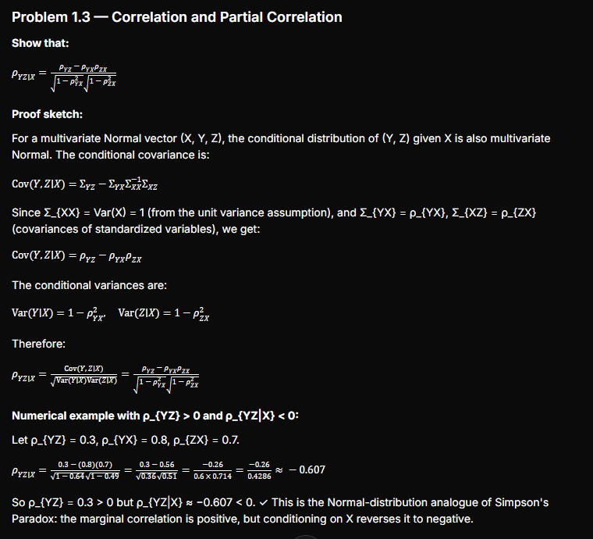

Show that:
ρYZ∣X=ρYZ−ρYXρZX1−ρYX21−ρZX2\rho_{YZ|X} = \frac{\rho_{YZ} - \rho_{YX}\rho_{ZX}}{\sqrt{1-\rho_{YX}^2}\sqrt{1-\rho_{ZX}^2}}
Proof sketch:
For a multivariate Normal vector (X, Y, Z), the conditional distribution of (Y, Z) given X is also multivariate Normal. The conditional covariance is:
Cov(Y,Z∣X)=ΣYZ−ΣYXΣXX−1ΣXZ\text{Cov}(Y, Z | X) = \Sigma_{YZ} - \Sigma_{YX}\Sigma_{XX}^{-1}\Sigma_{XZ}
Since Σ_{XX} = Var(X) = 1 (from the unit variance assumption), and Σ_{YX} = ρ_{YX}, Σ_{XZ} = ρ_{ZX} (covariances of standardized variables), we get:
Cov(Y,Z∣X)=ρYZ−ρYXρZX\text{Cov}(Y, Z | X) = \rho_{YZ} - \rho_{YX}\rho_{ZX}
The conditional variances are:
Var(Y∣X)=1−ρYX2,Var(Z∣X)=1−ρZX2\text{Var}(Y|X) = 1 - \rho_{YX}^2, \quad \text{Var}(Z|X) = 1 - \rho_{ZX}^2
Therefore:
ρYZ∣X=Cov(Y,Z∣X)Var(Y∣X)Var(Z∣X)=ρYZ−ρYXρZX1−ρYX21−ρZX2\rho_{YZ|X} = \frac{\text{Cov}(Y,Z|X)}{\sqrt{\text{Var}(Y|X)\text{Var}(Z|X)}} = \frac{\rho_{YZ} - \rho_{YX}\rho_{ZX}}{\sqrt{1-\rho_{YX}^2}\sqrt{1-\rho_{ZX}^2}}

Numerical example with ρ_{YZ} > 0 and ρ_{YZ|X} < 0:
Let ρ_{YZ} = 0.3, ρ_{YX} = 0.8, ρ_{ZX} = 0.7.
ρYZ∣X=0.3−(0.8)(0.7)1−0.641−0.49=0.3−0.560.360.51=−0.260.6×0.714=−0.260.4286≈−0.607\rho_{YZ|X} = \frac{0.3 - (0.8)(0.7)}{\sqrt{1-0.64}\sqrt{1-0.49}} = \frac{0.3 - 0.56}{\sqrt{0.36}\sqrt{0.51}} = \frac{-0.26}{0.6 \times 0.714} = \frac{-0.26}{0.4286} \approx -0.607
So ρ_{YZ} = 0.3 > 0 but ρ_{YZ|X} ≈ −0.607 < 0. ✓ This is the Normal-distribution analogue of Simpson's Paradox: the marginal correlation is positive, but conditioning on X reverses it to negative.

Problem 1.4 — Specification Searches
Using the cps1re74.csv data with 10 covariates, there are 2¹⁰ = 1,024 possible subsets. The chapter shows:
- All covariates included: β = +1,067.5 (p = 0.054, marginally not significant)
- No covariates: β = −8,506.5 (p < 0.001, significantly negative)
The expectation is that most models with few covariates yield negative-significant coefficients (mimicking the unadjusted result), while models with many covariates tend toward positive coefficients. This demonstrates how fragile regression-based "causal effects" are to arbitrary covariate selection — a key motivation for the formal causal inference framework developed later in the book.
Specification search insightinfo
The number of positive-significant, negative-significant, and non-significant treatment coefficients across 1,024 regressions illustrates that researcher discretion over covariates can manufacture nearly any conclusion — reinforcing the need for principled causal methods like propensity score matching or DAG-based adjustment.
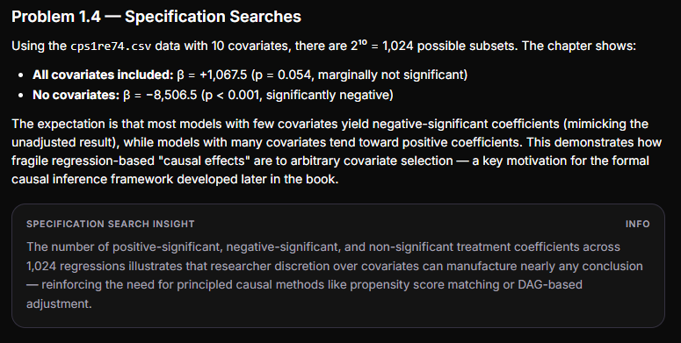

Problem 1.5 — Subgroup Analysis by Gender
Using the resume data from Bertrand & Mullainathan (2004), separating callbacks by applicant gender and perceived race:
- Male resumes: Compare callback rates for Black-sounding vs. White-sounding names within male resumes.
- Female resumes: Same comparison within female resumes.
The expected finding (consistent with the original study) is that both subgroups show the same pattern: White-sounding names receive more callbacks regardless of gender, with similar effect sizes. This confirms the racial discrimination finding is not driven by gender composition — no Simpson's Paradox here. The Fisher's exact test should remain significant in both subgroups, though possibly with reduced power due to smaller sample sizes.
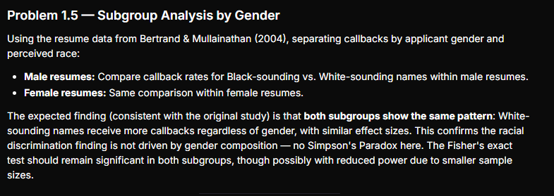

5. 🧠 Chapter Mindmap
The mindmap image above provides a visual overview of Chapter 1, organized around five branches: Measures of Association, Simpson's Paradox, Key Concepts, Methods, and Homework Problems.

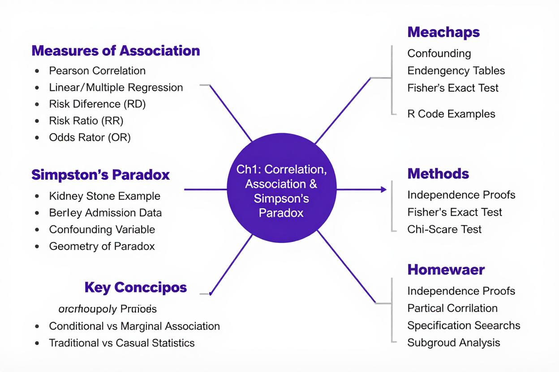

6. 🏆 Top 5 Topic Applications for Practical Projects
Top 5 Practical Applicationsinfo
Each application maps chapter concepts to real-world projects with measurable impact.
Rank | Application | Description | Chapter Concepts Used
1 | Healthcare Treatment Evaluation | Evaluate whether a new treatment protocol is truly effective by checking for Simpson's Paradox across patient severity strata. Compute RD, RR, OR for each stratum and compare to the aggregate. | Contingency tables, RD/RR/OR, Simpson's Paradox, confounding, Fisher's exact test
2 | HR Analytics & Fairness Audits | Audit hiring or promotion decisions for demographic bias. Replicate the Berkeley admissions methodology: compute aggregate admission/promotion gaps, then stratify by department or role to detect Simpson's Paradox. | Stratified analysis, chi-square test, confounding detection, risk difference
3 | A/B Test Integrity Checking | In non-randomized product experiments, verify that observed lift in conversion rates isn't reversed when stratified by user segment (device, geography, acquisition channel). Detect confounders that could flip conclusions. | Conditional vs. marginal association, specification search, regression sign-flip detection
4 | Marketing Campaign Attribution | Assess whether a marketing campaign genuinely drives sales or whether confounders (seasonality, customer segment, prior engagement) create a spurious association. Run all-covariate-subset regressions to assess robustness. | Multiple regression, confounding, specification search, correlation vs. causation
5 | Education Policy Impact Assessment | Evaluate whether a curriculum intervention improves test scores. Compare marginal improvement to subgroup-level improvements by socioeconomic status, prior achievement, and school type to ensure observed gains aren't a Simpson's Paradox artifact. | Stratified contingency analysis, conditional risk differences, confounding variables, hypothesis testing
Yes, the .json notebook is complete. Here's a confirmation of its structure:
Notebook JSON Validationinfo
The notebook is a valid Jupyter Notebook (.ipynb) with 8 cells (2 markdown + 6 code), proper kernelspec and language_info metadata, and nbformat 4.
Here's a breakdown of what it contains:
Cell # | Type | Section
1 | Markdown | Title & overview
2 | Code | Section 1: Pearson correlation & simple vs. multiple regression
3 | Code | Section 2: 2×2 contingency table analysis (RD, RR, OR, Fisher, χ²)
4 | Code | Section 3: Simpson's Paradox detector
5 | Code | Section 4: Kidney stone worked example
6 | Code | Section 5: Berkeley admissions worked example
7 | Code | Section 6: Specification search (all 2^p covariate subsets)
8 | Markdown | Usage instructions
Validity checklist:
- ✅ Valid JSON syntax (proper quoting, no trailing commas, no comments)
- ✅ Required top-level keys: cells, metadata, nbformat, nbformat_minor
- ✅ Each code cell has cell_type, execution_count, metadata, outputs, source
- ✅ Each markdown cell has cell_type, metadata, source
- ✅ Kernelspec and language_info metadata are populated
- ✅ All functions are self-contained (depend only on numpy, pandas, scipy, statsmodels)
- ✅ Both worked examples (kidney stones + Berkeley) use the exact numbers from the chapter
You can save the JSON block directly as causal_inference_ch1_template.ipynb and open it in Jupyter or any compatible environment.

